CIS 425 Assignment 2

Planning a Meal Online

Due Monday February 7 at midnight.

I'll post instructions for submitting the homework soon.

For this assignment you will create a tool for ordering food. As the customer makes decisions, the food will appear on a dish. You will be building a GUI interface.

The goal is to write a GUI from scratch, using the tools we have. So **don't go looking** for GUI packages, or for examples of GUI code. You'll be able to do it yourself, and just in case, there will be keys for doing the same tasks.

There will be two windows: one the **food selection window (**GUI) and the other a **food display window** showing the food on the dish.

The **food selection window** will have radio buttons for various main courses of **your choice**. At the beginning, no main course is selected. The radio buttons should behave like radio buttons, be circles, filled in with a disc when selected. Once a choice has been made, exactly one radio button can be selected at any time, and when you click on one, the previous one's circle goes blank.

The **food selection window** will have check boxes for optional items: again, **you choose which ones to offer.** When a check box is checked, that item will be added to the dish.

The check boxes should behave like check boxes - when clicked an X should appear in the box, and the item should appear on the plate. When clicked again, the X should disappear, and the item should be removed from the dish.

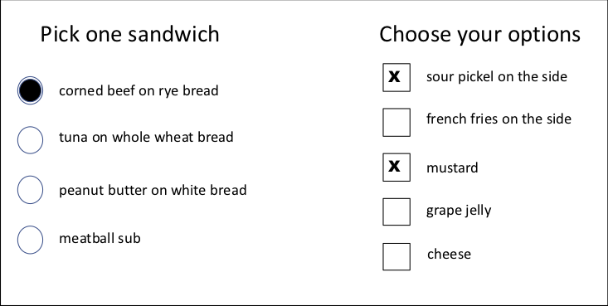

All clicks in the GUI should be done with the left mouse button.

The **food display window** should display the selected food items. As choices in the GUI window change, what we see in the food display window should change.

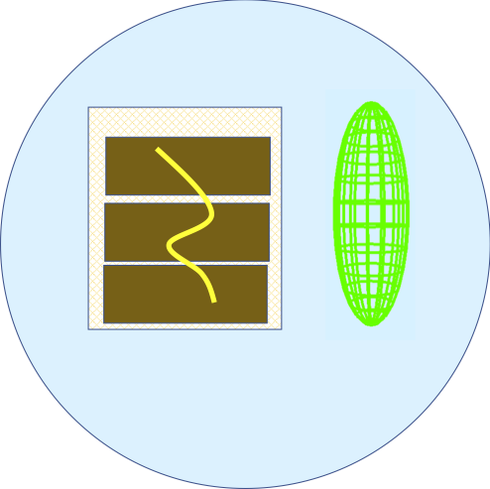

A pop-up menu (right mouse button activated) over the food display window will have submenus to: change the color of the dish, select a shape for the dish, rotate the dish and all the food on it around its center. What else would you like to set with the pop-up menu?

You might want an option to slice off a piece of the pickle or carrot or apple, using a clipping pane. A slider in the food selection window could be used to control the size of the dish, or....

You should have keyboard commands that do the same things as clicking on the food selection window.

Example: typing c for corned beef

* It should make the disc inside the corned beef circle appear and deselect whatever was previously selected.
* The corned beef sandwich should appear on the plate, and whatever main dish was there before should be removed.
* It would be nice if the food selection panel displayed what the keyboard equivalent is.

**I recommend you get the keyboard versions working early**, in case you have problems with the mouse clicks in the food selection window.

What you need to have:

* Two windows: a food selection window and a food display window.
* Check boxes with the options to be displayed. They should behave like checkboxes.
* Labels for the check boxes
* Radio buttons for the main dishes. They should behave like radio buttons.
* Labels for the radio buttons
* A dish with appropriate food visible in the food display window.
* A pop-up menu in the food display window with submenus that change the color of the plate, rotate the plate, change the shape of the plate.
* Some of the items on the plate should be built from 3D glut primitives, rendered in wire mode.
* Thought should be given as to which items are on top of which. (For example, my corned beef is on top of the bread, and the optional mustard is on the corned beef.) There must be some depth testing using the depth buffer.
* Keyboard commands that do the same things as your GUIs.

Some other things you might try: You may make your items more or less complex. You might use clipping planes to display a wedge of apple. You may decide no one should get mustard with peanut butter, so mustard will be greyed out and not selectable when the peanut butter is selected. You may want to have a slider in the food selection window that gradually changes the size of the plate. You might want to be able to drag food on the plate. A good challenge is to have the GUI buttons still work properly after the food selection window is resized. Lots of opportunities to play! And please, come up with your own main courses. Pasta? Sushi? Pastries? ...

Tips:

1. For clicking the radio button, count any click in the surrounding square.
2. Have all the radio buttons control **one** int variable. Different values for different buttons. This variable will then control which circle has a disc drawn in it and what main dish is displayed in the food display window.
3. Each check box has its own boolean variable. This variable will then control whether an X is drawn in that box and whether we see that particular option.
4. A key for a check box will control the same boolean variable as in #3. A key for a radio button will control the same int variable as in #2.